**Rush Order - SOW**

-The admin can readily enable the extension from Magento backend from This path: STORES -> Settings -> Configuration -> RUSH ORDER CONFIGURATION -> Rush Order and set Status "Yes" or "No". also Option to set a custom extra name (like Rush Order) for title to display in-store frontend.

-Once the store owner sets the price from the Magento backend, Rush order charges will automatically be applied to the storefront. Along with the order total, it will be set on its own.

-The Rush order charges will be displayed on the cart page and checkout page with the total order that is calculated.

-The admin can also set the minimum order amount from the store backend. If the order amount matches the minimum set amount only then the extra fee will be displayed on the front end.

- Once you have successfully installed the extension, go to STORES -> Settings -> Configuration -> RUSH ORDER CONFIGURATION -> Rush Order to configure the extension for use.

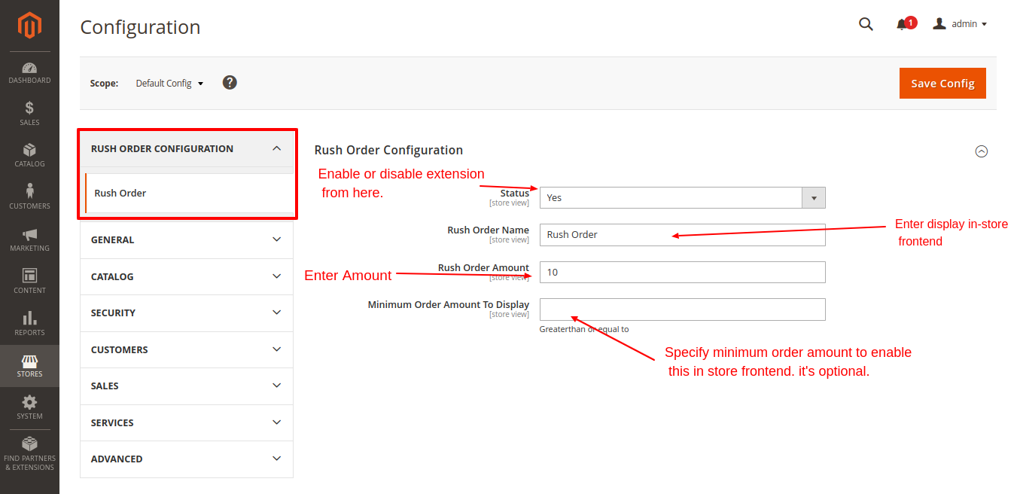

You can see Rush order in your checkout page.

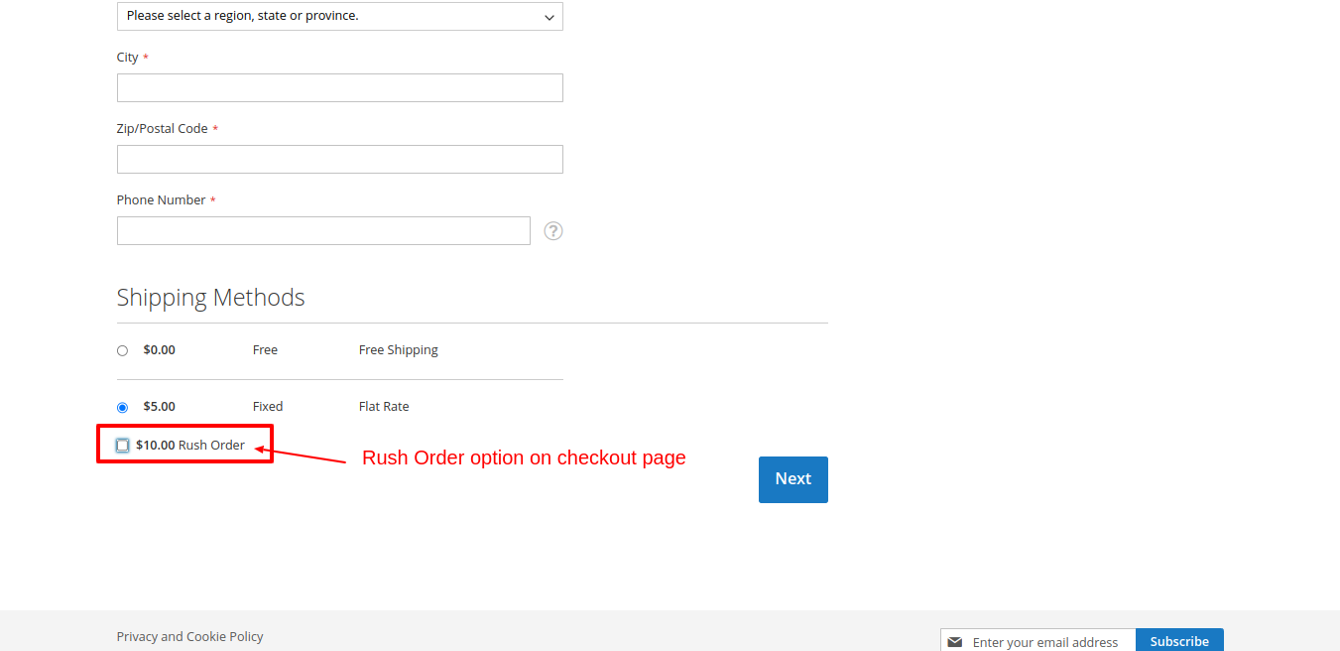

you can see an Rush Order applied in the store frontend shopping cart page.

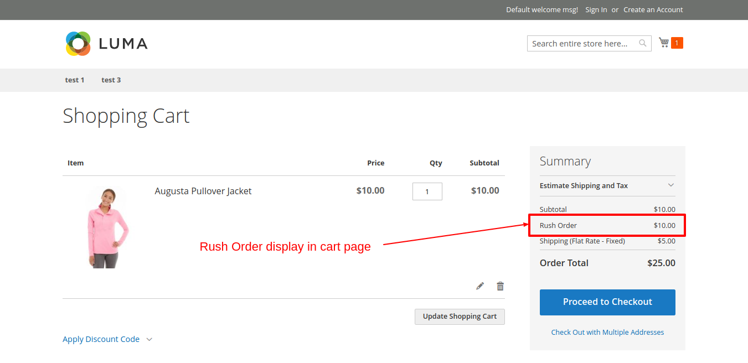

You can also see Order Rush in your checkout order summary.

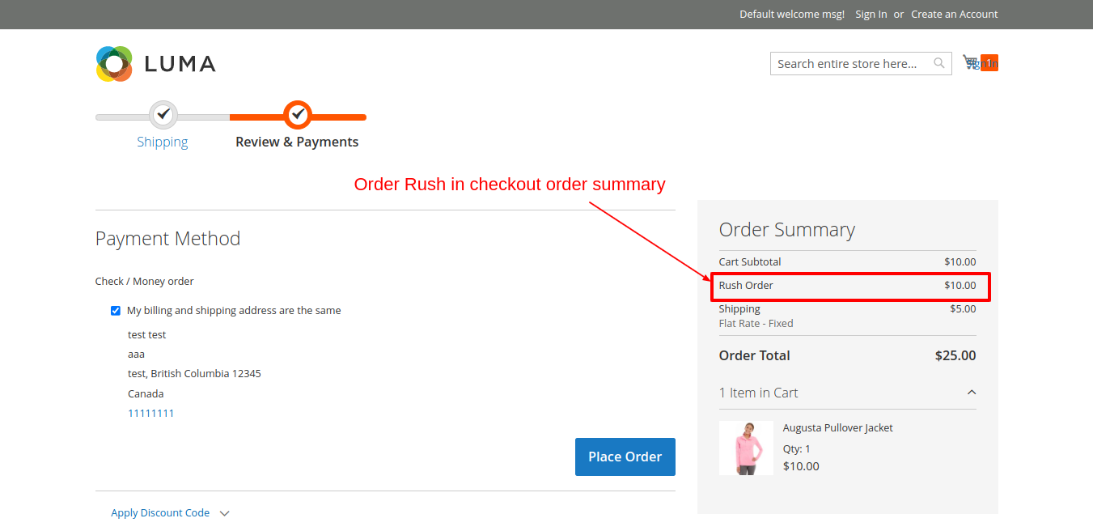

Once your customer has placed an order from the store frontend, the admin can also see Rush Order in the backend order view.

